SEDAS — Project Log
Week 1 Submission — Inception & Elaboration Phase
MIS5320 Applied IS Project — Part B · Assessment 1 (In-class Project Log Review)
Unit | MIS5320 Applied IS Project – Part B, Apex Australia Higher Education
Project | SEDAS — Social Engineering Defence and Awareness System (implementation of the Part A design by Ashraful Islam, MIS5203)
Team | Ashraful Islam (240135) · Huzaifa Iqbal (240220) · [member 3 — TBC] · [member 4 — TBC]
Supervisor | Dr Chandana Withana
Consultation slot | Thursdays 11:30
Repository | github.com/ailinkon/MIS5320-SEDAS-CyberProjectB (private; supervisor access available on request)
Methodology | Unified Process lifecycle (Construction & Transition); Agile DevSecOps + RAD practices within phases
Submission date | [insert date — Sunday Week 1]

1. Project Identification and Team Formation
Following the Week 1 class and Dr Withana's direction, the team has been formed around the implementation of SEDAS, the Part A project of Ashraful Islam. SEDAS is a layered defence against social engineering in higher education, combining an AI phishing-detection engine, a tamper-evident URL verification service, adaptive persona-based awareness training, and a governance dashboard. Team membership as at submission is recorded on the cover table; module allocations follow the RACI matrix in the Implementation Project Plan and will be finalised with any additional members at the first supervisor consultation (Thursday 11:30).

2. Inception & Elaboration Summary
Per the Unified Process, Week 1 was spent reviewing and refining the Part A specification into an implementable baseline before Construction. Two governing documents were produced and accompany this log:
- Specification Review & MVP Refinement Memorandum: consolidates the Part A requirements into numbered form (FR-01..FR-11, NFR-01..NFR-08), records eight formal refinement decisions (R-01..R-08) with justification — notably descoping Ethereum smart contracts to a hash-chained tamper-evident registry, replacing live LMS/SIEM/SSO integrations with mocked API contracts, and re-baselining latency targets for CPU hardware — and re-baselines ethics, security, privacy and sustainability commitments for a student implementation (public/synthetic data only, no real personal information).
- Implementation Project Plan: maps all eight weeks to UP phases, sprints and assessment milestones; defines the team RACI, the technology stack with justification against alternatives, the version-control and CI workflow, the testing strategy, and a seven-item risk register.
Presented for specification sign-off at the Week 1/Week 2 consultation, after which the baseline is frozen per the unit schedule.

3. Cumulative Time-Indexed Log
Entry 1 — 9 July 2026 — Repository establishment
Decisions (with justification): Dedicated Part B repository created for a clean implementation history (Part A design artefacts remain referenced from the original repository). Repository set to private during the assessment period for academic-integrity reasons; to be made public after grade release. Microservice folder layout adopted per Implementation Project Plan §4.
Ethics/security/privacy: No secrets committed; .env.example configuration pattern adopted; datasets and trained model binaries excluded from version control.
Tools/AI disclosure: Claude used for planning documents and repository structure guidance; structure reviewed and created manually by the team.
Entry 2 — 9 July 2026 — Baseline detection model (FR-01, NFR-01)
Work completed: Baseline phishing-detection model trained. Dataset: Kaggle combined public corpus (Nazario, Enron, SpamAssassin, CEAS, Ling, Nigerian), 82,486 emails, 80/20 stratified split. Pipeline: TF-IDF (50k features, 1–2 grams) + Logistic Regression (balanced class weights).
Results (16,498 held-out emails): Accuracy 0.9859 · Precision 0.9867 · Recall 0.9862 · F1 0.9865 (Part A target ≥ 0.95: MET) · False-positive rate 0.0144 (target < 0.02: MET). Confusion matrix TN=7805, FP=114, FN=118, TP=8461.
Reflection: Results are on public research corpora; live institutional traffic would likely show lower performance due to domain shift. A DistilBERT comparison is planned per the Implementation Plan (R-04 gap-analysis approach).
Tools/AI disclosure: scikit-learn, pandas; training script scaffolded with Claude, reviewed and executed by the team.
Entry 3 — 9 July 2026 — Classification API (FR-01, FR-02, FR-09, NFR-03)
Work completed: /classify REST endpoint implemented (FastAPI) exposing the model with explainability — returns label, risk score 0–100, top contributing indicators, and measured latency. Auto-generated OpenAPI documentation at /docs; /health endpoint for service monitoring.
Testing: Manual functional tests: phishing sample scored 98.07/100 with explainable indicators (account, http, click, verify, immediately) at 9.4 ms; legitimate sample scored 0.85/100 at 10.8 ms — both against the NFR-03 target of < 2,000 ms (met by >100× on CPU hardware, also under the original Part A GPU-assumed 200 ms target). A malformed-input negative test returned HTTP 422 with a descriptive validation error, confirming server-side input validation (NFR-05). Evidence in Appendix A.
Tools/AI disclosure: FastAPI, uvicorn, joblib; API scaffolded with Claude, reviewed and tested by the team.
Entry 4 — 9 July 2026 — Team formation
Work completed: Group formation initiated per Dr Withana's Week 1 email. Huzaifa Iqbal (240220) confirmed as team member; recruitment of further members in progress via the class thread. Project confirmed as SEDAS (implementation of A. Islam's Part A design) per the unit requirement. Consultation slot Thursdays 11:30 confirmed.
Entry 5 — 9 July 2026 — Automated testing and CI
Work completed: Automated test suite created (TD-01..TD-05) covering service health, phishing detection, legitimate pass-through, explainability, and latency — all five passing (4.3 s), each traced to a requirement ID (FR-01, FR-02, FR-09, NFR-03). GitHub Actions CI pipeline added: pytest runs on every push and pull request.
Design decision: The suite auto-skips on machines without the locally trained model, since the dataset and model binary are deliberately excluded from the repository; CI therefore validates imports and the test harness, with model-free unit tests to follow.
Tools/AI disclosure: pytest, FastAPI TestClient; suite scaffolded with Claude, executed and verified by the team.

4. Ethical, Sustainability, Security and Privacy Considerations (Week 1)
- Data and privacy. All model training and evaluation used public research corpora only; no live institutional email or real personal data has been or will be processed in the MVP (Australian Privacy Principles compliance by design).
- Consent in simulation. Any simulated-phishing demonstrations will be confined to seeded test accounts operated by team members, preserving the informed-consent commitments of Part A §5.1.
- Security of the artefact. Repository hygiene enforced from day one: no credentials in version control, environment-variable configuration, datasets and binaries excluded. An OWASP Top 10 self-assessment of the artefact is scheduled for Week 6.
- Sustainability. GPU inference and cluster orchestration descoped (R-05, R-06), materially reducing the energy footprint of the build while CPU-scale results already exceed the quality KPIs.

5. Interim Versions and Progress Against KPIs
KPI (Part A §4.5) | Target | Week 1 result | Status
Phishing detection F1 | ≥ 0.95 | 0.9865 (held-out set) | Met
False-positive rate | < 2% | 1.44% | Met
Classification latency | < 2,000 ms (refined, R-05) | ≈ 11 ms (CPU) | Met
Risky-click reduction (RBCR) | 30% (simulated demo) | Scheduled — Transition phase | Pending
Training uptake > 80% | Deferred (no real user population) | Documented as future work | Deferred (R-register)
Interim version: detection service v0.1-dev (model + API + test suite) in the main branch; first tagged release (v0.1, integrated MVP) is scheduled for Week 4 per the Implementation Project Plan.

6. Plan for Week 2
- Specification sign-off with supervisor (freezing the baseline per the unit schedule).
- Team completion and module allocation against the RACI (frontend/dashboard, awareness training module, URL verification service).
- Onboarding: repository access, environment setup from requirements.txt, teach-back session on the detection service.
- Commence URL verification service — hash-chained tamper-evident registry with external reputation lookup (FR-03, FR-04, refinement R-01).

7. Attachments
- Specification Review & MVP Refinement Memorandum (Word)
- Implementation Project Plan (Word)
- Evidence screenshots embedded in Appendix A below (originals retained in docs/evidence/ in the repository)

Appendix A — Week 1 Evidence

A.1 Repository establishment (Entry 1)
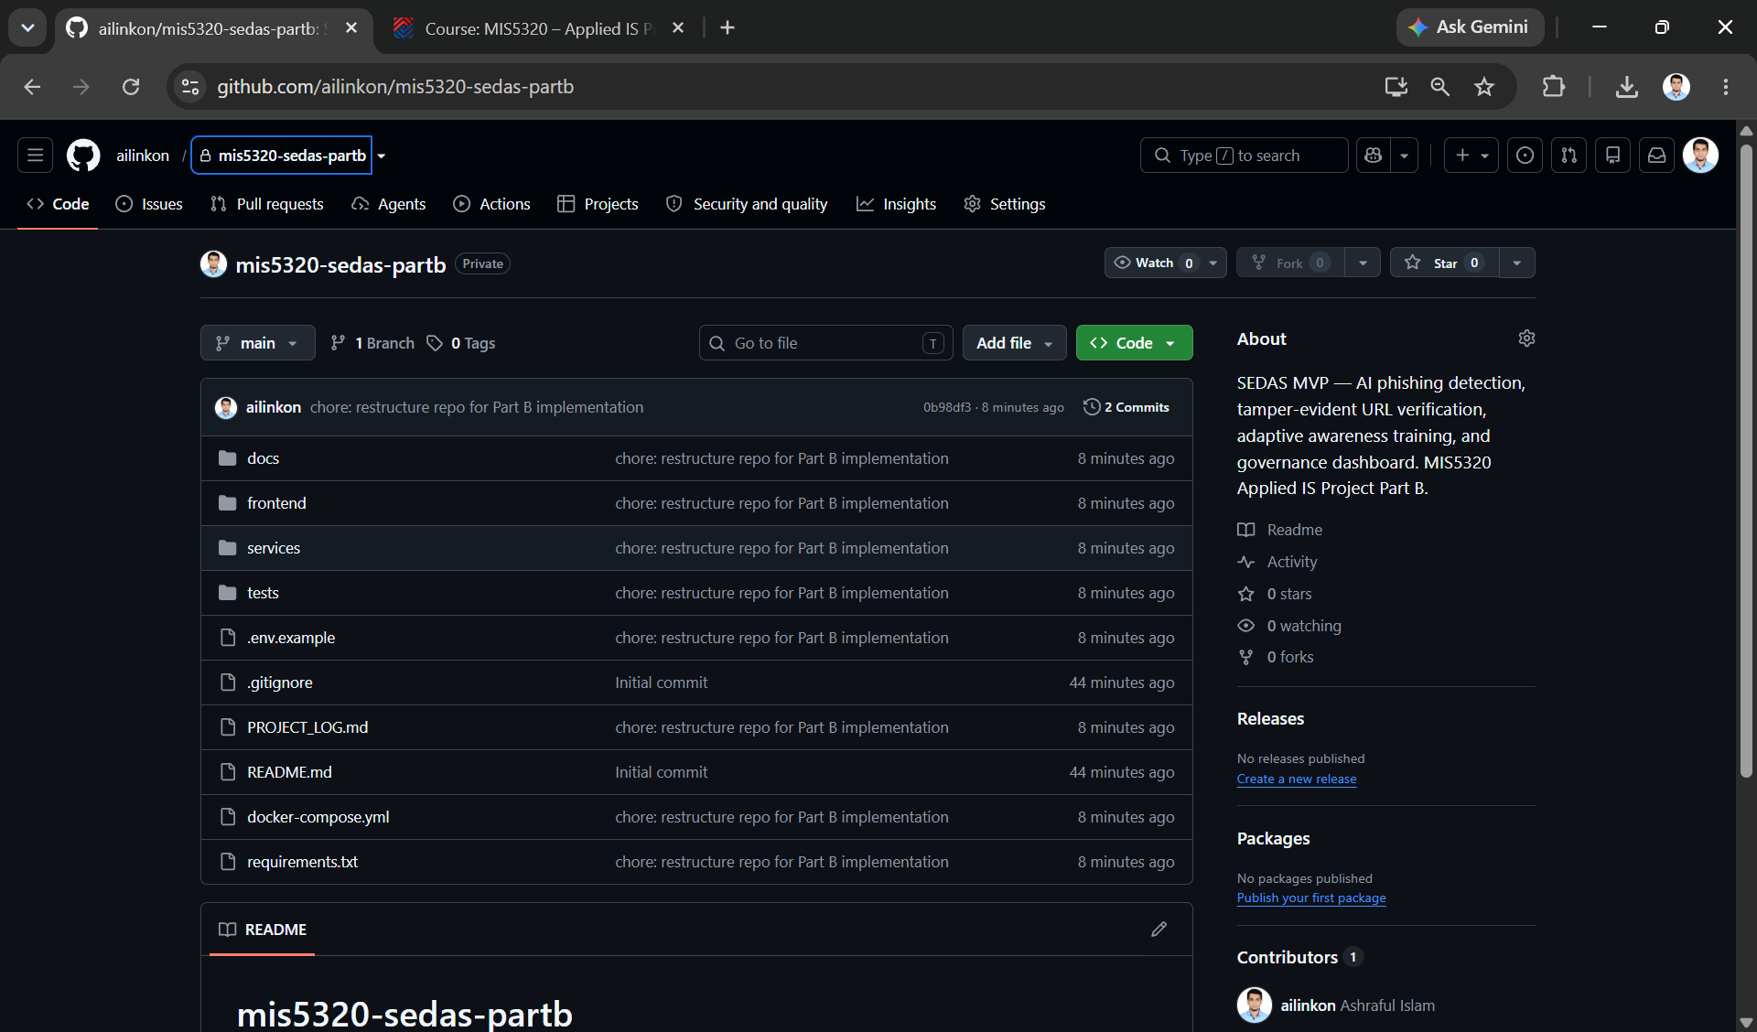
Figure 1. Private Part B repository (mis5320-sedas-partb) with microservice structure, PROJECT_LOG.md, and 'chore: restructure repo for Part B implementation' commit.
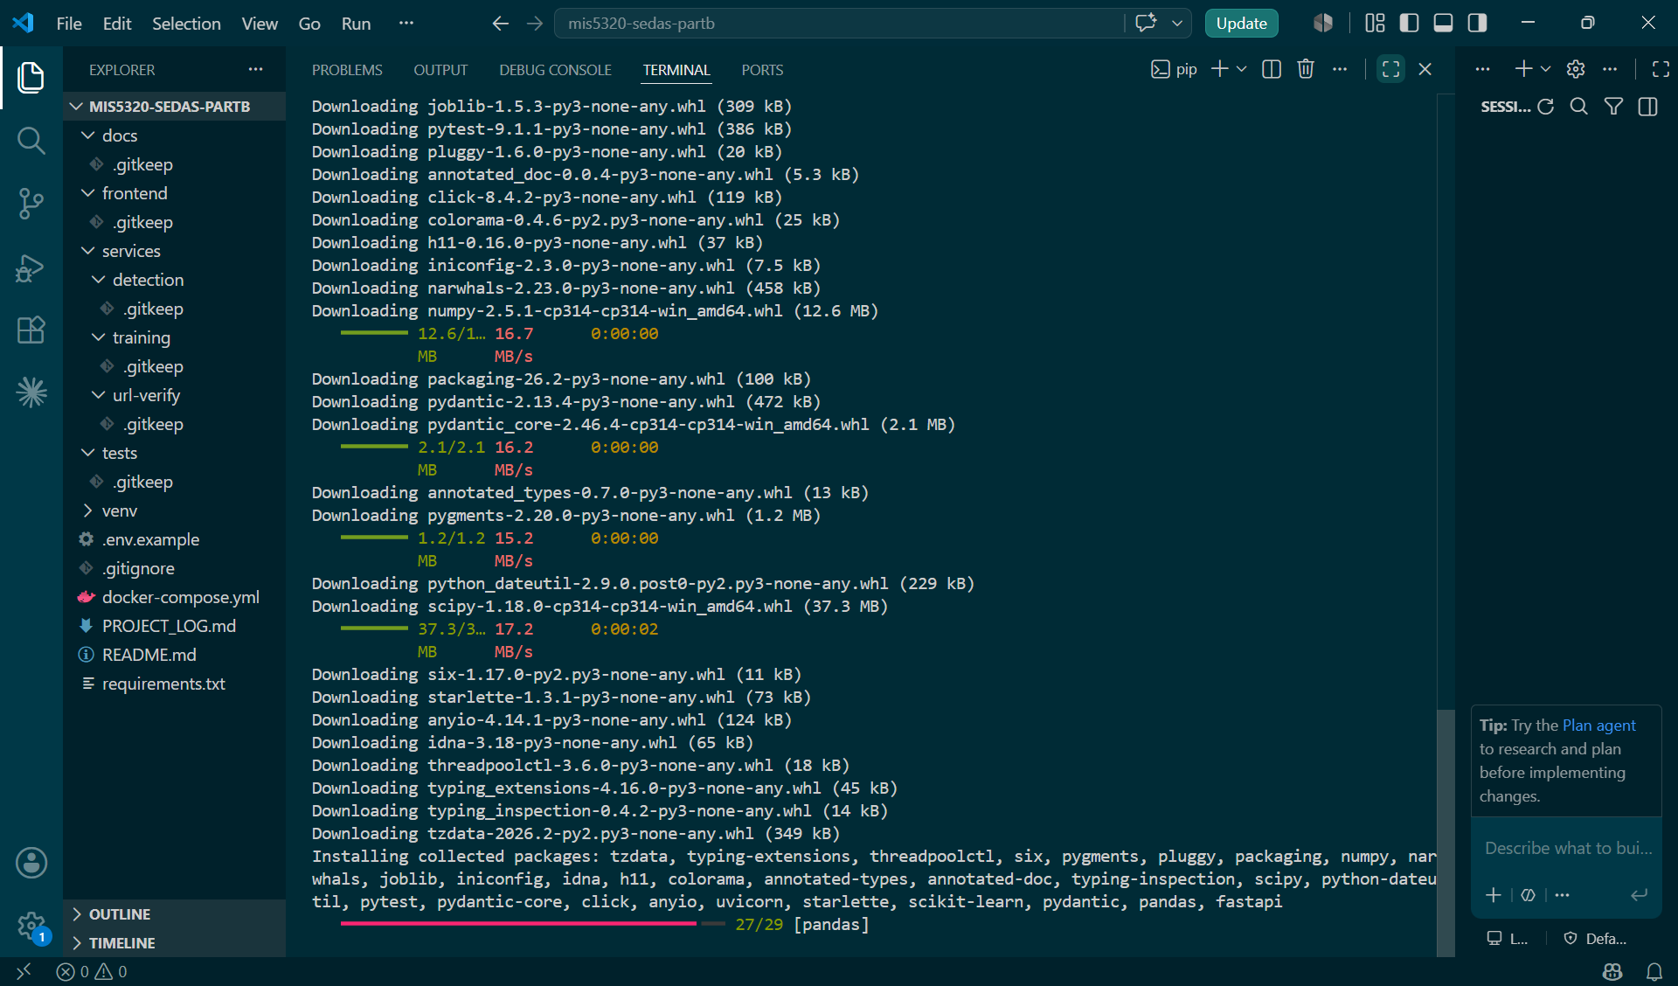
Figure 2. Reproducible development environment: dependency installation into the project virtual environment within the repository workspace.

A.2 Detection service API (Entry 3)
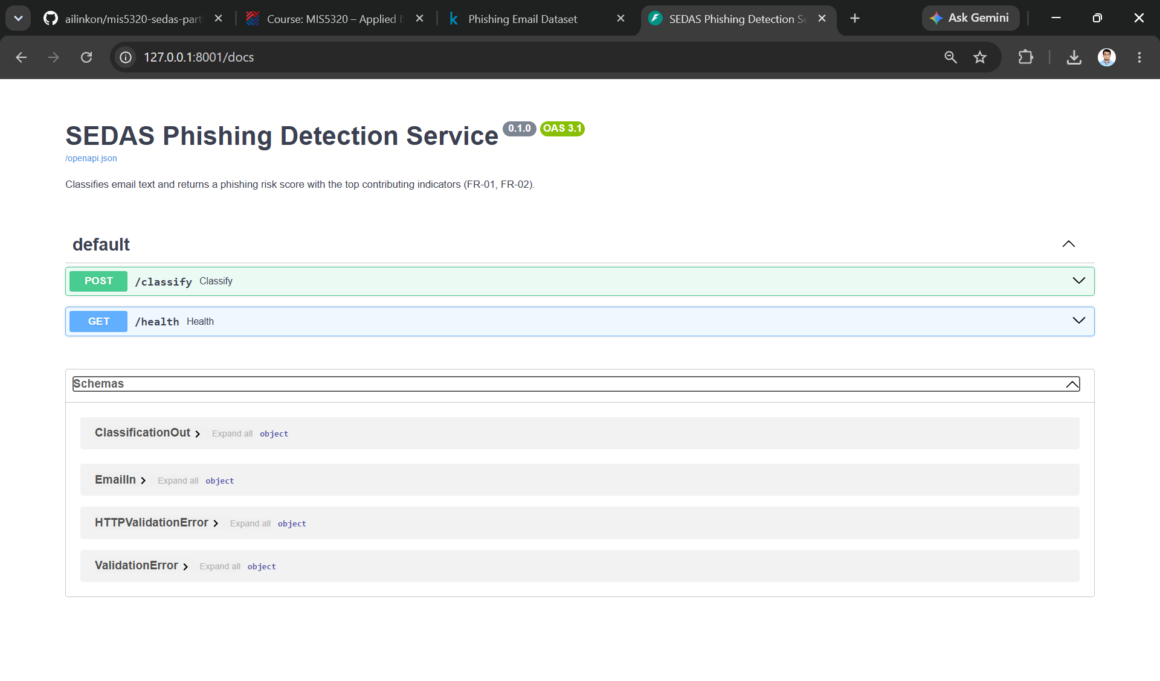
Figure 3. Auto-generated OpenAPI documentation for the SEDAS Phishing Detection Service v0.1.0 — /classify and /health endpoints with typed schemas (FR-09).
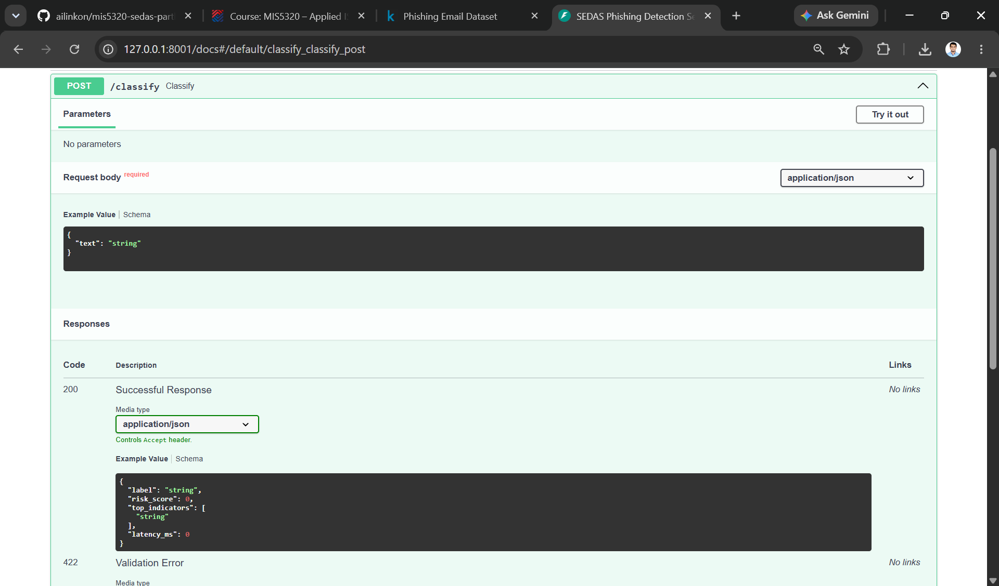
Figure 4. /classify endpoint contract: required JSON request body and typed response model (label, risk_score, top_indicators, latency_ms) implementing FR-01 and FR-02.

A.3 Functional testing (Entry 3)
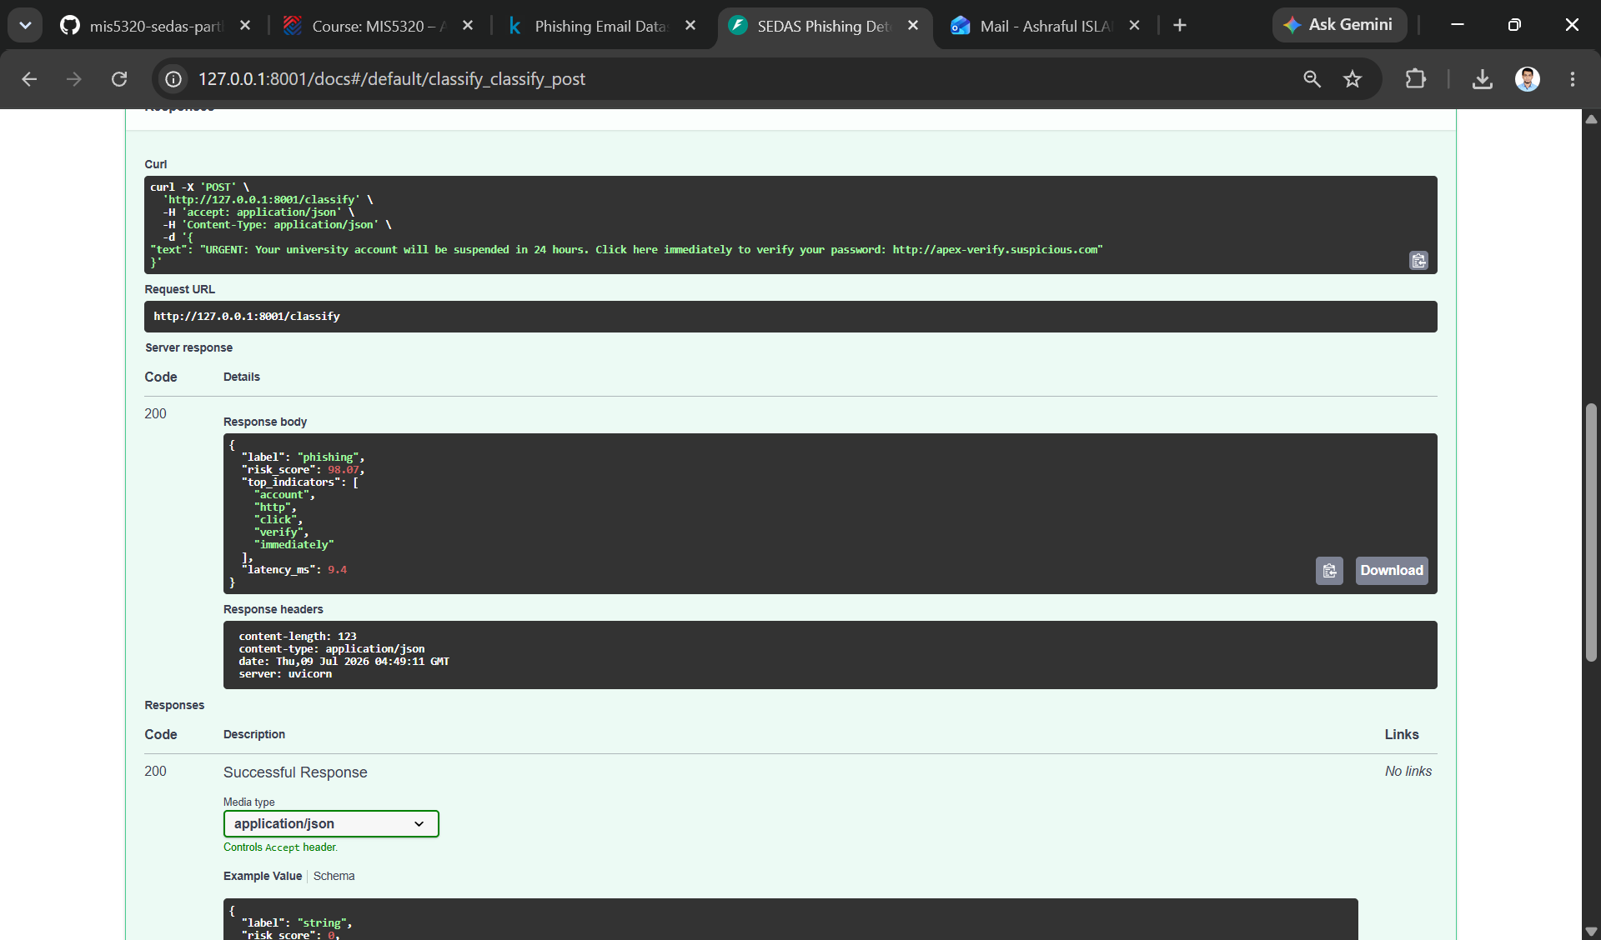
Figure 5. Live classification of a simulated phishing email: label 'phishing', risk score 98.07/100, explainable indicators (account, http, click, verify, immediately), latency 9.4 ms (FR-01, FR-02).
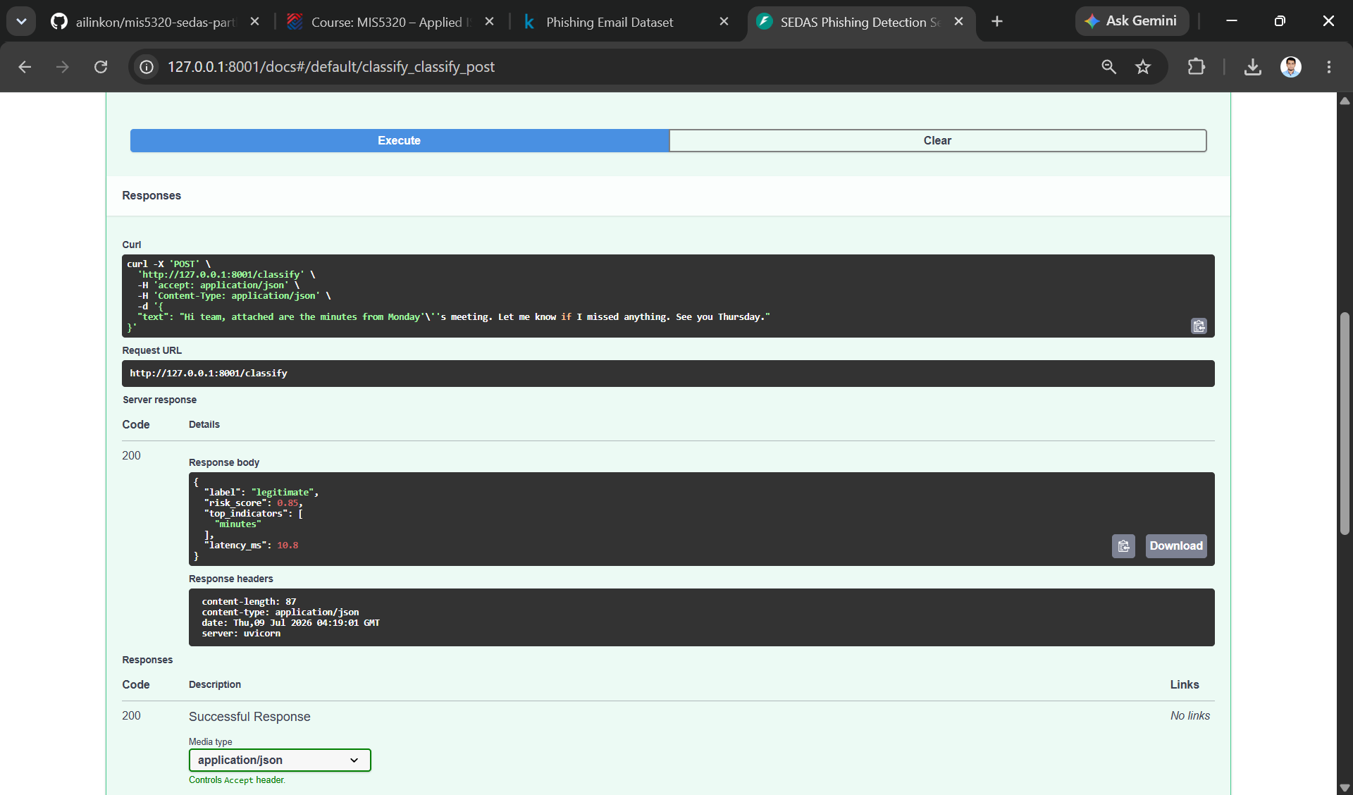
Figure 6. Live classification of a legitimate email: label 'legitimate', risk score 0.85/100, measured latency 10.8 ms against the NFR-03 target of < 2,000 ms.
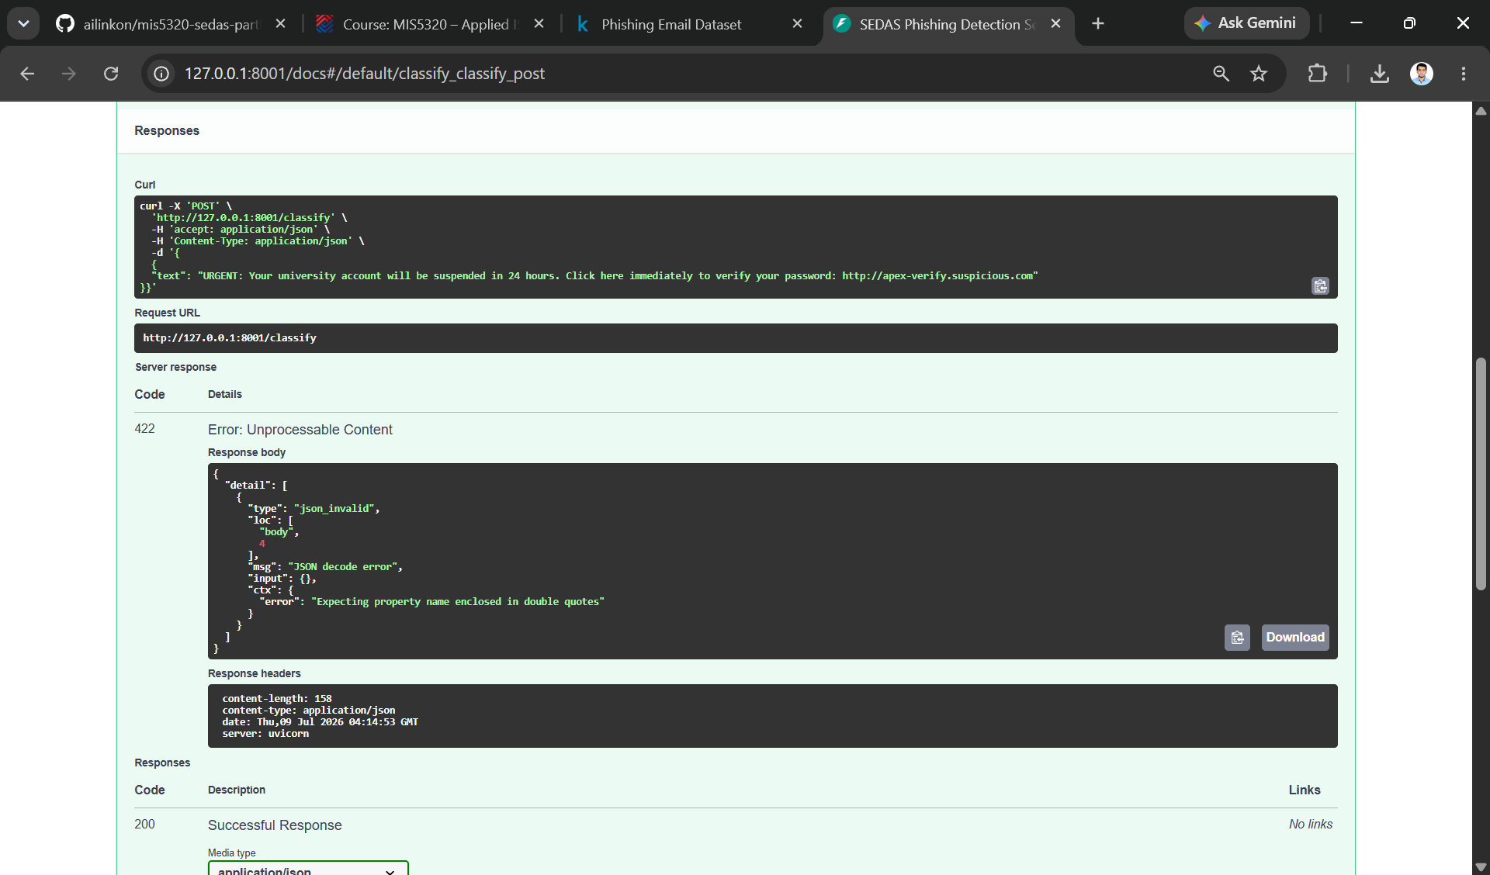
Figure 7. Negative test: malformed JSON input correctly rejected with HTTP 422 and a descriptive validation error — server-side input validation working as designed (NFR-05).

A.4 Project Log under version control (Entries 1–5)
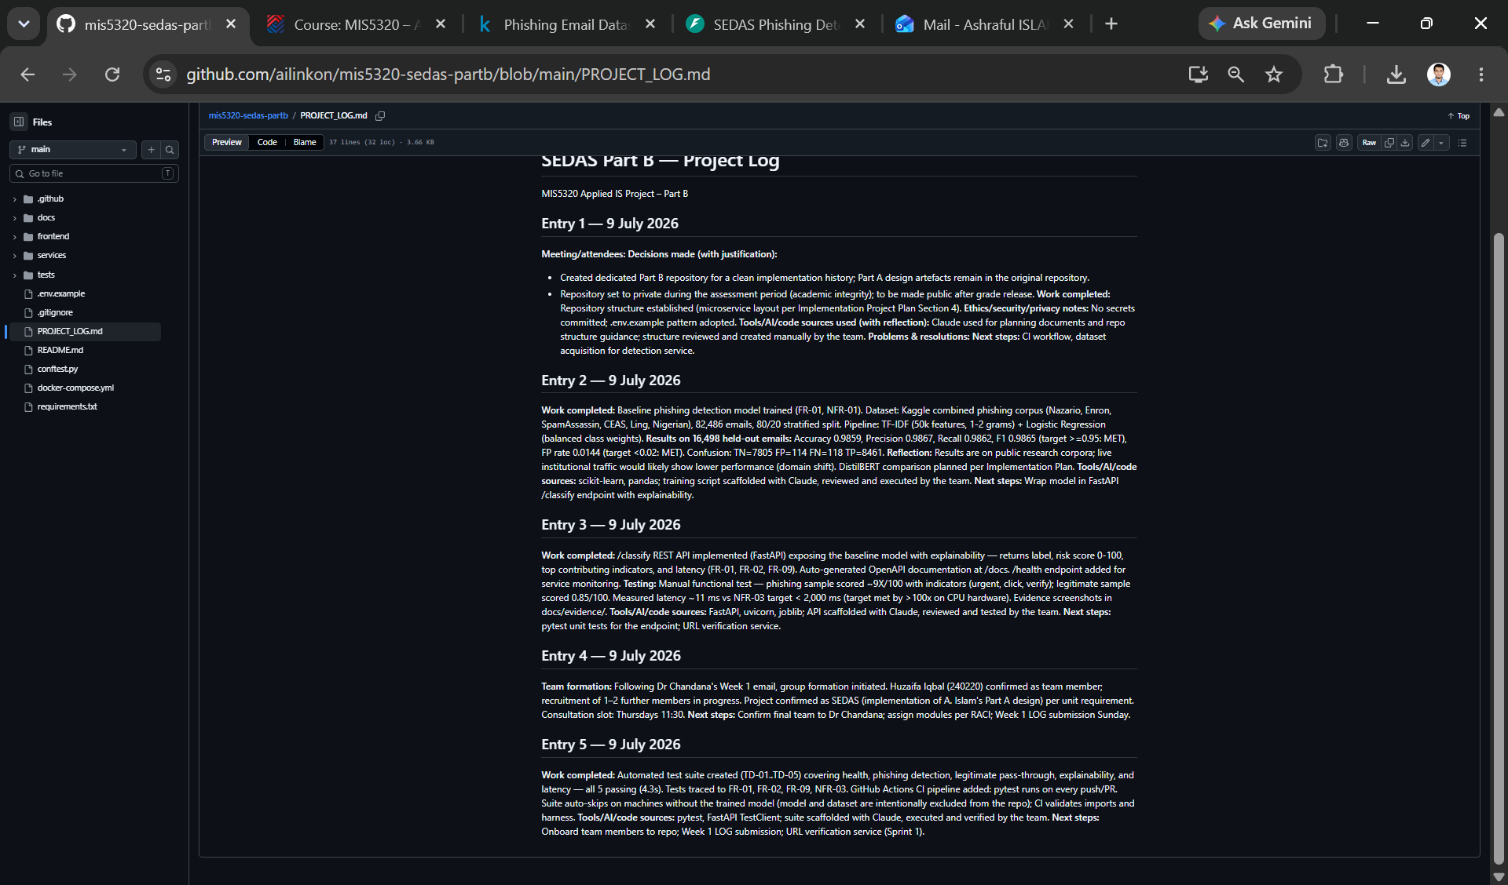
Figure 8. Cumulative time-indexed Project Log (Entries 1–5) maintained in the repository, with per-entry decisions, justifications, and AI/tool disclosure.

